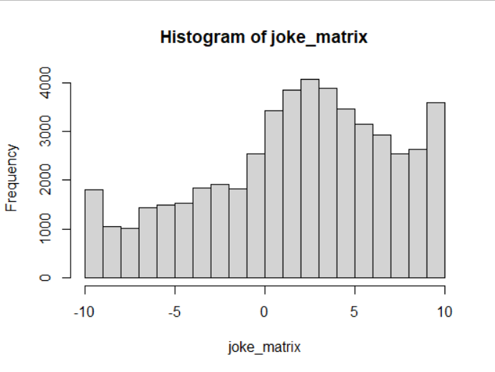

Data Cleaning : id which has combination of user_id and joke_id is not considered in this observation

We have taken user_id as userid=23340

user_id joke_id Rating

<dbl> <dbl> <dbl>

1 23340 130 1.31

2 23340 136 -1.31

3 23340 103 -7.06

This user has given only negative so far and only positibve is also just 1 . Considering the content found on jokes must be offensive.

We will recommend base on the positive rating given

Similar rating is given by user 39365 with rating of 1.375.

user_id ---39365

joke_id---2

Rating ------1.375

Joke_id of 2 is recommended for user_id 39365.

# user with maxnimum rating given as 10

joke_rating[which.max(joke_rating$Rating),]

|  |
| --- |
| id user_id joke_id Rating |
| <chr> <dbl> <dbl> <dbl> |
| 1 40838_102 40838 102 10 |

#user with lowest rating given for joke

joke_rating[which.min(joke_rating$Rating),]

|  |
| --- |
| id user_id joke_id Rating |
| <chr> <dbl> <dbl> <dbl> |
| 1 18502_122 18502 122 -10 |

>

Recommending the joke for the user who has givne the lowest rate

userid=18502

jokes_final <- subset(joker, joker$user_id==userid)

print("You have rated these jokes :")

jokes_final

print("recommendations for you:")

prediction <- predict(rec1, R[userid], n=5) ## n= no of recommendation

as(prediction, "list")

$`31236`

[1] "96" "22" "49" "93" "122"